**Macintosh HD:Users:gwilliams:Documents:My Work:My Work:ALL FILES:Active:Maths General:PLC Crest:PLC Crest and Byline.eps**

**NAME:_____________________________________________________**

**TEST 5: Sampling, Vector Calculus and Vectors**

Date: 26th August 2016

**SECTION ONE: CALCULATOR FREE**

TOTAL: 23 marks

EQUIPMENT: Pens, pencils, pencil sharpener, highlighter, eraser, ruler, SCSA formula sheet.

WORKING TIME: 25 minutes maximum

**SECTION TWO: CALCULATOR ASSUMED**

TOTAL: 35 marks

EQUIPMENT: Pens, pencils, pencil sharpener, highlighter, eraser, ruler, drawing instruments, templates, up to 3 Calculators,

1 A4 page of notes (one side only), SCSA formula sheet.

WORKING TIME: 35 minutes minimum

Show all your working clearly. Your working should be in sufficient detail to allow your answers to be checked readily and for marks to be awarded for reasoning. Incorrect answers given without supporting reasoning cannot be allocated any marks. For any question or part question worth more than two marks, valid working or justification is required to receive full marks. If you repeat an answer to any question, ensure that you cancel the answer you do not wish to have marked.

|  |  |  |  |  |  |
| --- | --- | --- | --- | --- | --- |
| **SECTION 1**  **Question** | **Marks available** | **Marks awarded** | **SECTION 2**  **Question** | **Marks available** | **Marks awarded** |
| **1** | **12** |  | **4** | **5** |  |
| **2** | **5** |  | **5** | **14** |  |
| **3** | **6** |  | **6** | **11** |  |
|  |  |  | **7** | **5** |  |
|  |  |  |  |  |  |
|  |  |  |  |  |  |
| **Total** | **23** |  |  | **35** |  |
|  |  | **Overall** | **Total** | **58** |  |

**Calculator-free 25 minutes [23 marks]**

This paper has **Three (3)** questions. Answer **all** questions. Write your answers in the spaces provided

**Question 1 [12 marks]**

The position in metres from an origin of a particle after t seconds can be modelled by the position vector:

(Note:  and  and )

(a) Find the Cartesian equation of the curve defined by the position vector. (4)

(b) Sketch the position vector and indicate the direction of motion using . (3)

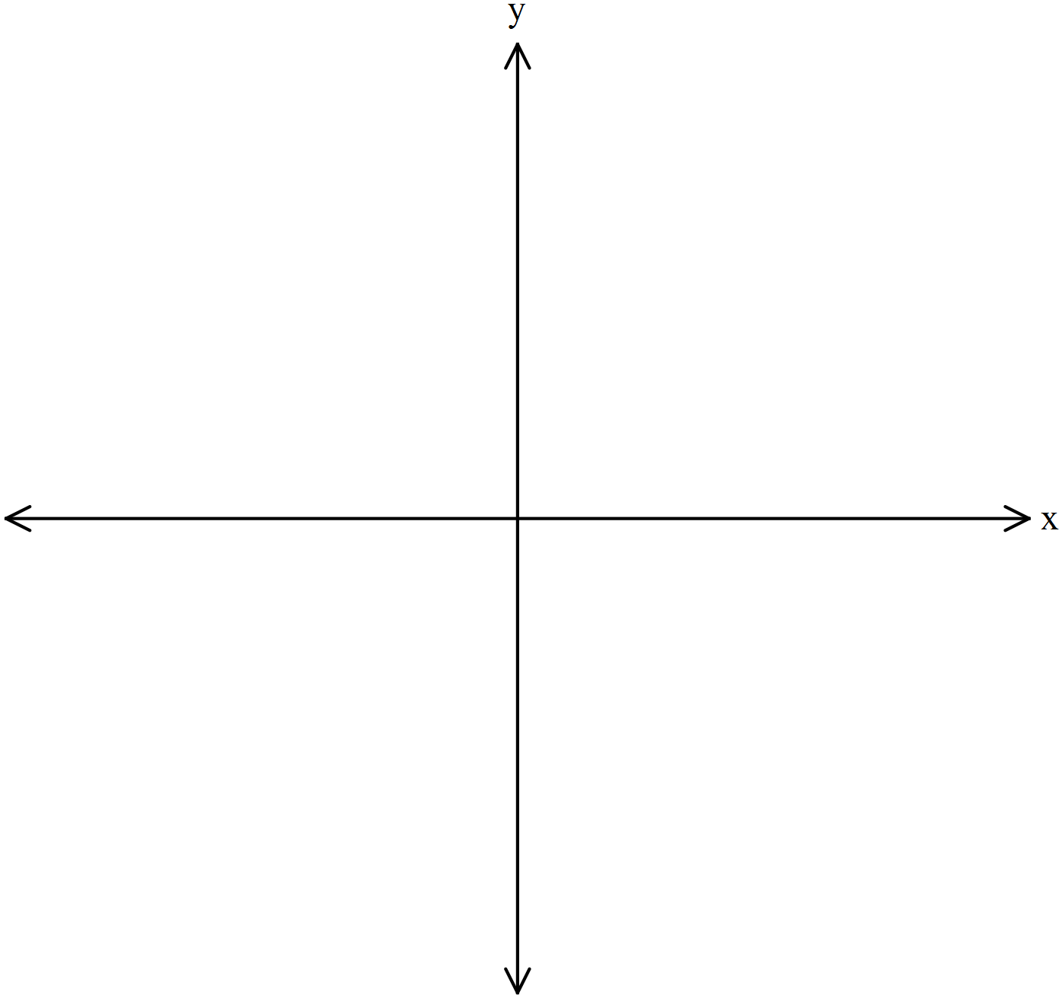

(c) Determine the velocity vector  . (3)

(d) Calculate the speed of the particle at . (2)

**Question 2 [5 marks]**

Determine the equation of the plane consisting of all points that are equidistant from  and .

**Question 3 [6 marks]**

A plane  has vector equation 

(a) Show that the Cartesian equation of the plane  is  (3)

(b) The plane  meets the  and  axes at A, B and C respectively. Find the coordinates of A, B and C. (2)

(c) Find the volume of the pyramid OABC. (1)

**NAME:____________________________________________________**

**Calculator Allowed 35 minutes [35 marks]**

This paper has **Four (4)** questions. Answer **all** questions. Write your answers in the spaces provided

**Question 4 [5 marks]**

The length of time, T, in months, that a football manager stays in his job before he is removed can be approximately modelled by a normal distribution with population mean  and population variance.

An independent sample of 25 managers is taken. The mean time for this sample is 13 months.

(a) Determine a point estimate for. (1)

(b) Find the 95% and 99% confidence interval for . (2)

(c) The mean time for a second sample is exactly 15 months. Using the confidence intervals from part b) determine with reasons if the managers in this sample stayed in the job longer than those in the first sample. (2)

**Question 5 [14 marks]**

The velocity vector of a particle P at time  hours is given by  kilometres per hour. It is known that the initial position of the particle is .

(a) Determine , the position vector of P at time  hours. (2)

(b) Show that the speed of P at time  hours is given by  (2)

(c) Find the position vector of P when its speed is maximised for the first time. (2)

A second particle Q has position vector at time  hours is given by  kilometres per hour. P and Q start moving at the same time.

(d) Sketch on the axes below the paths of particles P and Q. (3)

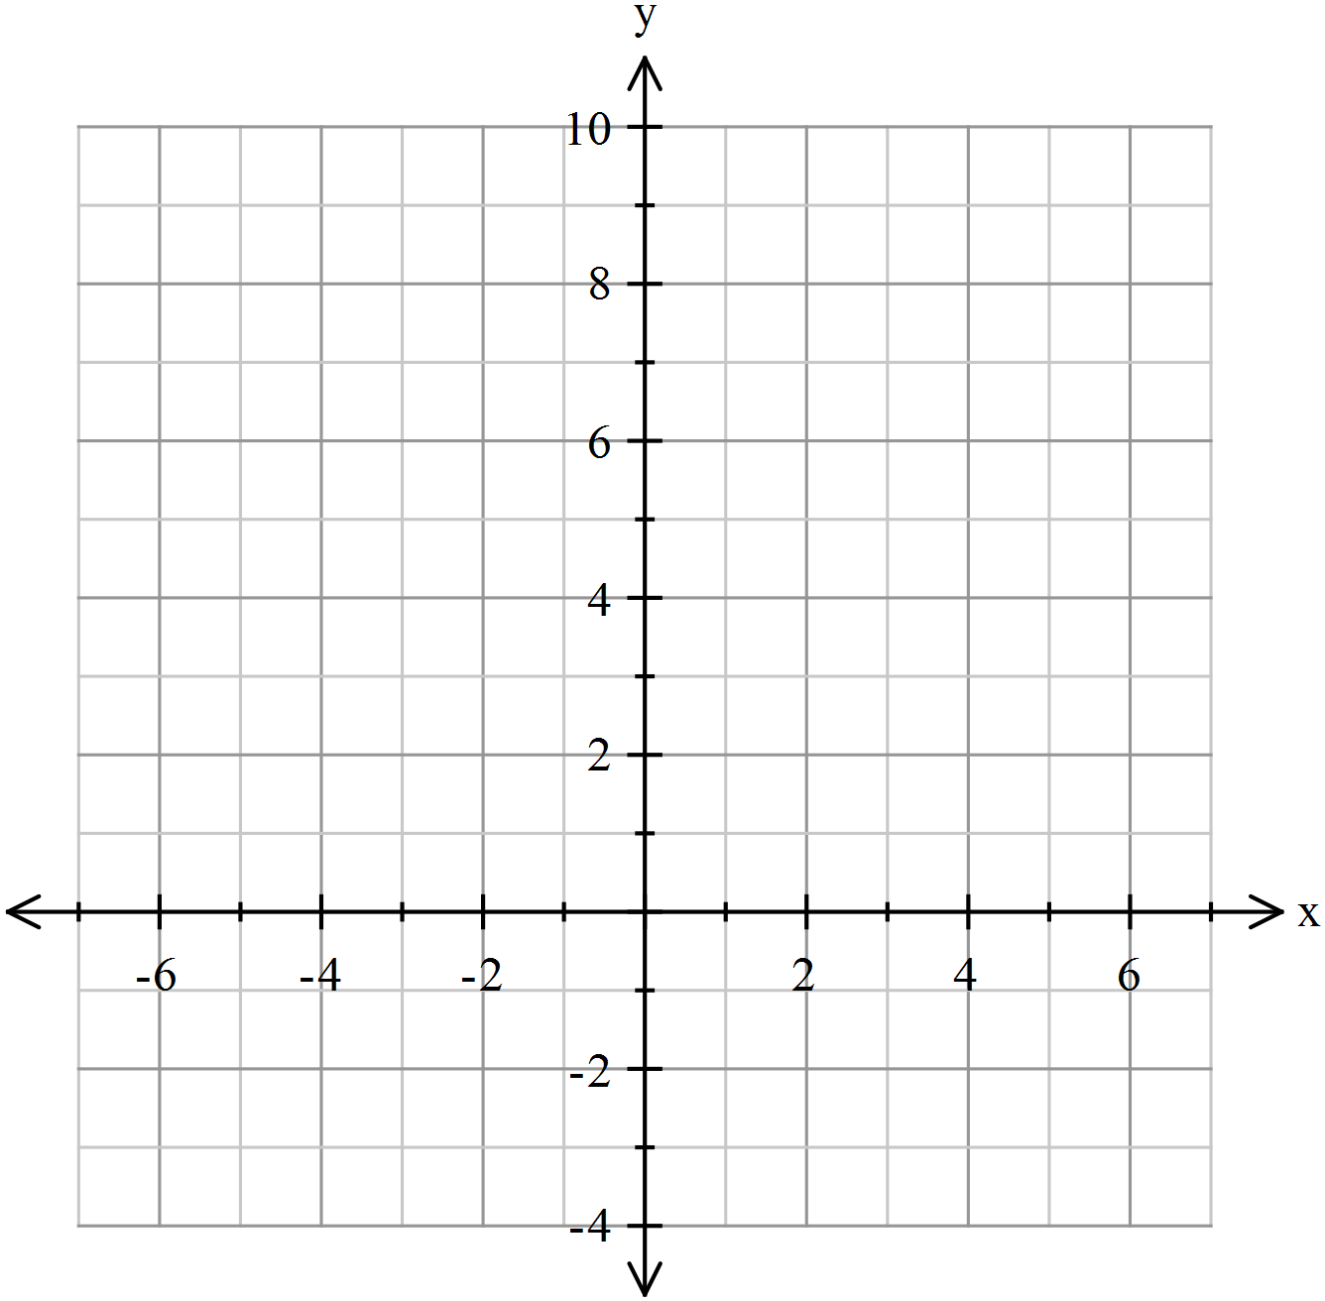

(e) Determine the period of particle Q. (1)

(f) Show that whilst the paths of the two particles cross twice, the two particles do not collide. (4)

**Question 6 [11 marks]**

A person standing on top of a 35 m high cliff throws a stone into the water with velocity 16 ms−1 at an angle of 30° to the horizontal.

(a) Using the origin as the base of the cliff, derive the vector equations for the velocity and position of the stone (let g = 10 m s−2 and neglect air resistance). (5)

(b) Derive the Cartesian equation of the stone’s flight as a function of y in terms of x. (3)

(c) Calculate the time that the stone will take to land in the water and its distance from the foot of the cliff

at that time. (3)

**Question 7 [5 marks]**

Jack and Ben are athletes specialising in the long jump. When Jack jumps, the length of his jumps are normally distributed with a mean 5.2 metres and standard deviation 0.1 metres. When Ben jumps, the lengths of his jumps are normally distributed with a mean 5.1 metres and standard deviation 0.12 metres. For both athletes, the length of a jump is independent of all other jumps. During a training session, Jack makes four jumps and Ben makes three jumps.

(a) Let  and  denote the mean of Jack’s and Ben’s jumps respectively. The distributions of and  can be described as  and . Determine the values of *a*, *b*, *c* and *d*. (2)

(b) Using the fact that , calculate the probability that the mean length of Jack’s four jumps is less than the mean length of Ben’s three jumps. (3)

**END OF QUESTIONS**